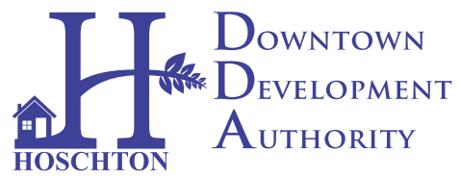
Hoschton Downtown Development Authority (DDA)
Board Member Application

Thank you for your interest in serving on the Hoschton's Downtown Development Authority (DDA) as a Board Member. Please take the time to read this application thoroughly before applying.
Being a DDA Board Member is a wonderful way to serve your community. It is not an easy job, but it is most definitely important, interesting, fulfilling, and exciting work. If you are voted to serve as a Board Member on the DDA Board, it is expected that you will attend one monthly board meeting (typically 60-90 minutes), as well as dedicate 10 to 15 hours/month outside of the Board meeting to conduct DDA business. It is best if Board Members have a somewhat flexible work schedule, as some DDA activities, meetings, and training may occur during normal business hours. Every effort will be made to alleviate inconveniences when possible. If you are unable to devote the necessary time, energy, and enthusiasm to the DDA, please do not apply.
It is crucial that the DDA be a strong, committed, and viable organization-- we need a member with the same characteristics if we are going to achieve goals. If you are unable to commit to Board service at this time, there are still many other ways in which you may volunteer and help revitalize our Historic Downtown through numerous special projects and committee activities. We hope that you will continue to be involved, be supportive, and volunteer… just let us know!
The powers of the Downtown Development Authority were established by special State legislation and approved by the City of Hoschton. The DDA is an independent authority established for the purpose of planning, organizing, and financing projects that will revitalize and redevelop Hoschton’s commercial business district. The DDA focuses on the historic commercial downtown central business district and works to market a positive image for the town.
As such, Board Members agree to be bound as Board Members by bylaws and ethical provisions set forth in State and local law. According to DDA bylaws, Board Members may include, but are not limited to, representatives from the City of Hoschton; Hoschton Downtown Business Association; Jackson County Chamber of Commerce; or other citizens of Georgia who have business in the City of Hoschton or pay property/business taxes in Jackson County.

DDA Board Member Application

1. Name:
2. Address:
3. Phone:
4. Email:
5. How long have you been associated with the city either by living or owning a business:

6. Where are you currently employed? What is your current position? How long have you been with this company? If Self-employed, provide business Name and Address (A resume may be attached to provide professional information)

7. Either in the space below or on a separate attachment, please list any special skills or experience that you feel would be strengths for the DDA. (Professional experience, previous Board experience, volunteerism, personality characteristics, etc.)

8. In the space below or on a separate attachment, please list your “vision” for the future of downtown Hoschton, and how you think Hoschton could work towards these goals.

How can you help this process?

I have read and fully understand this application for the DDA Associate Membership. I am willing to make a commitment to the revitalization of Downtown Hoschton and assist the DDA.

_________________________________ ___________________
Signature Date

