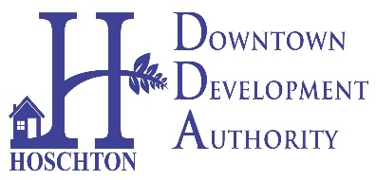
CITY OF HOSCHTON
DOWNTOWN DEVELOPMENT AUTHORITY
MONDAY, SEPTEMBER 11, 2023
HOSCHTON COMMUNITY CENTER AT 6:00PM
65 CITY SQUARE, HOSCHTON

MINUTES
WELCOME AND CALL TO ORDER – 6PM BY TRACY JORDAN
8/14 MEETING MINUTES APPROVAL- APPROVED BY JOE VOGT SECOND BY MARSHA HUNTER AND ALL IN FAVOR
AGENDA APPROVAL- APPROVED BY SRI KUMAR SECOND BY MARIYA BENTZ AND ALL IN FAVOR
EXECUTIVE SESSION- FOR REAL ESTATE- BY TRACY JORDAN SECOND BY SRI KUMAR AND ALL IN FAVOR- EXECUTIVE SESSION – FOR REAL ESTATE- ADJOURN AT 6:39 BY MARSHA HUNTER- SECOND BY MARIYA BENTZ
- Oak Street Project Recommendation to Council- RECOMMENDATION TO MAYOR AND COUNCIL- PARAMOUNT LANDSCAPE GROUP.
- Update on 2024 Budget- LIFE PATH SIDEWALK- 7 YEAR PROJECT
- Update on Pickleball & BBQ- MET WITH CHELSEA FROM CRESSWIND- WILL SPEAK TO HER MANAGER TO DISCUSS FURTHER PARTNERSHIP.
- Larry’s Garage Update- NO UPDATE AT THIS TIME.
- New Discussions (If any)
PUBLIC INPUT-
CHAIRMAN RECAP- TRACY JORDAN THANKED AND UPDATED THE BOARD ON A SUCCESSFUL 2024.
ADJOURN- 6:47PM BY TRACY JORDAN SECOND BY MARSHA HUNTER AND ALL IN FAVOR.

