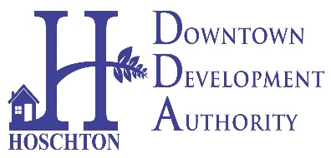
CITY OF HOSCHTON
DOWNTOWN DEVELOPMENT AUTHORITY
MONDAY, AUGUST 14, 2023
HOSCHTON COMMUNITY CENTER AT 6:00PM
65 CITY SQUARE, HOSCHTON

AGENDA
WELCOME AND CALL TO ORDER
7/10 MEETING MINUTES APPROVAL-
PUBLIC INPUT
- Oak Street Project Presentation
- Farmers Market Monthly updates
- Update on Cresswind Volunteer Fair
- Pickle Ball & BBQ Festival
- DDA Booth at Fall Festival
- Larry’s Garage Update
- New Discussions (If any)
ADJOURN-

