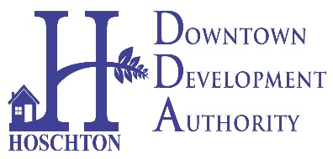
CITY OF HOSCHTON
DOWNTOWN DEVELOPMENT AUTHORITY
MONDAY, JULY 10TH, 2023
COMMUNITY CENTER AT 6:00PM
65 CITY SQUARE, HOSCHTON

AGENDA
WELCOME AND CALL TO ORDER
06/12 MEETING MINUTES APPROVAL
PUBLIC INPUT
- Oath of Office- Mr. Bob Loveland
- Oak Street Project Presentations.
- RFP on Larry’s Garage
- Discussion with SK Battery
- DDA Budget for 2024
- GDOT Sidewalk Project
- Farmer’s market Monthly Update
- DDA Table at Cresswind Volunteer Fair
- Jingle Mingle Committee
- Brick Fundraising for Oak Street Memorial Gardens
- New discussions (If Any)
ADJOURN

